CS 255 System Design Document Template

UML Diagrams

UML Use Case Diagram

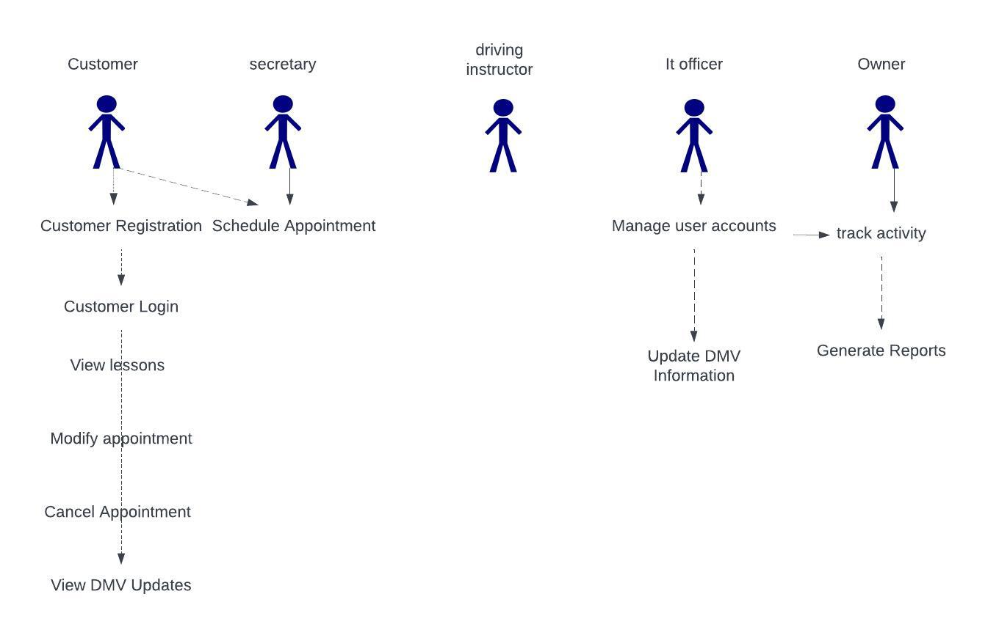

UML Activity Diagrams

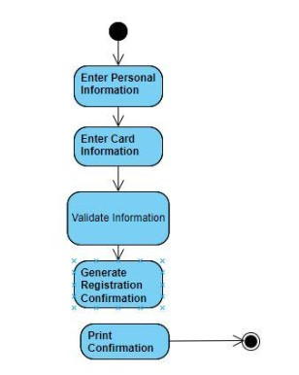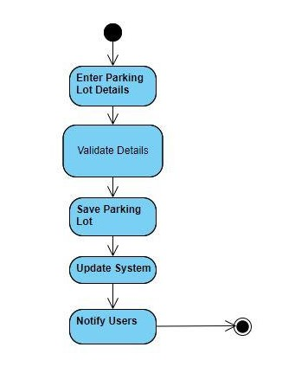

UML Sequence Diagram
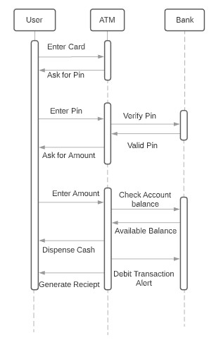

UML Class Diagram
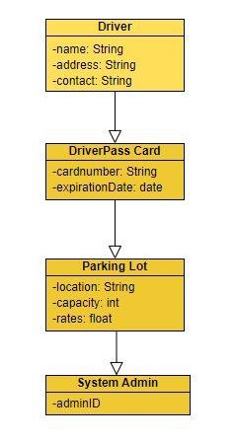

Technical Requirements
Technical Requirements for the System:
Hardware Requirements:
Server Infrastructure: The system will require a dedicated server to host the application and store data. The server should have sufficient processing power, memory, and storage capacity to handle concurrent user requests and data storage.
Database Server: A separate database server is needed to store and manage user data, parking lot details, and system configurations. It should have redundancy and backup capabilities to ensure data integrity.
Network Infrastructure: High-speed internet connectivity with redundancy to ensure the system's availability and responsiveness.
Printing Facilities: To enable the printing of registration confirmations and receipts, the system must be connected to printers, either locally or through networked printers.
Software Requirements:
Operating System: The server should run on a reliable and secure operating system, such as Linux or Windows Server, to host the application.
Database Management System (DBMS): Utilize a robust DBMS like PostgreSQL or MySQL to store and manage structured data efficiently.
Web Application Framework: Select a suitable web application framework, e.g., Django or Ruby on Rails, to build the web-based components of the system.
Programming Languages: Employ programming languages like Python, Java, or Ruby for server-side logic and scripting.
Web Server: Implement a web server, such as Apache or Nginx, to handle HTTP requests and ensure the application's scalability.
Version Control: Use a version control system like Git to manage source code, facilitate collaboration, and ensure codebase integrity.
IDE (Integrated Development Environment): Developers should use IDEs like Visual Studio Code or PyCharm for coding and debugging.
Software for Diagrams: Utilize UML modeling software, like Visual Paradigm or Lucidchart, to create and maintain UML diagrams.
Security Requirements:
Authentication and Authorization: Implement robust user authentication and authorization mechanisms to ensure that only authorized users can access and perform actions within the system.
Data Encryption: Use encryption protocols (e.g., HTTPS) to secure data transmission between clients and the server.
Secure Data Storage: Employ encryption and access control mechanisms to protect sensitive data stored in the database.
Regular Security Audits: Conduct regular security audits and vulnerability assessments to identify and mitigate potential security risks.
Development and Testing Tools:
Integrated Development Environment (IDE): Developers should use IDEs like Visual Studio Code, PyCharm, or Eclipse for coding and debugging.
Testing Frameworks: Utilize testing frameworks (e.g., Selenium for UI testing, JUnit for Java) for comprehensive testing of the application.
Continuous Integration/Continuous Deployment (CI/CD): Implement CI/CD pipelines with tools like Jenkins or GitLab CI to automate testing and deployment processes.
Infrastructure and Scalability:
Load Balancing: Implement load balancing to distribute incoming traffic evenly among multiple server instances to ensure high availability and scalability.
Cloud Integration (Optional): Consider using cloud services like AWS, Azure, or GCP for scalability and redundancy.
Documentation:
Technical Documentation: Create detailed technical documentation for the system, including architecture diagrams, database schema, API documentation, and code comments.
Training:
Developer Training: Ensure that development teams are trained in the chosen programming languages, frameworks, and tools.
User Training: Provide user training and documentation for system administrators, drivers, and system administrators.
Maintenance and Support:
Maintenance Plan: Develop a maintenance plan to regularly update and patch the system to address security vulnerabilities and improve functionality.
Customer Support: Establish a customer support system for addressing user inquiries, issues, and providing technical assistance.

